**ANALYSING HOUSING PRICES IN METROPOLITAN AREAS OF INDIA**

**Submitted by**

**Team id**

NM2023TMID19985

**Team members id**

1.YUVASRI.G 6C56857ABAFA27EADA84054CB5186541

**(Team Leader)**

2.GAAYATHRI. R 25B8BD177FFDA8D8E7F4A80FA142E11C

3.HEMA.K 732C7C0FE363819BD314B6308F8ACDD2

4.INDHUMATHI.S FE1DB9FB8AAA92CB9714C1FA5F5E7CA3

**Under the guidance of**

**Dr. K. Lilly MaryEucharista**

**Assistant Professor**

**Department of Physics**



**Sri Meenakshi Government Arts College for Women (A)**

**Madurai – 625 002**

**1.INTRODUCTION**

**1.1 OVERVIEW**

About the housing prices in metropolitan cities.

**1.2 PURPOSE**

**USE:** By analysing the housing prices in metropolitan areas of India ,gives a clear idea opportunities for potential house buyers.

The estate agents will easily connect with the buyers and sellers with reasonable housing .

The investors from low income families can also invest in properties and houses.

Housing financial companies and Indian commercial banks controls 90% of the market.

**ACHIEVEMENT**

20130.79 crore have been approved in 881 cities for construction of more than 1504 lakh Dwelling units.

**2.PROBLEM DEFINITION AND DESIGN THINKING**

**2.1 EMPATHY MAP**



**2.2.IDEATION AND BRAINSTORMING MAP**

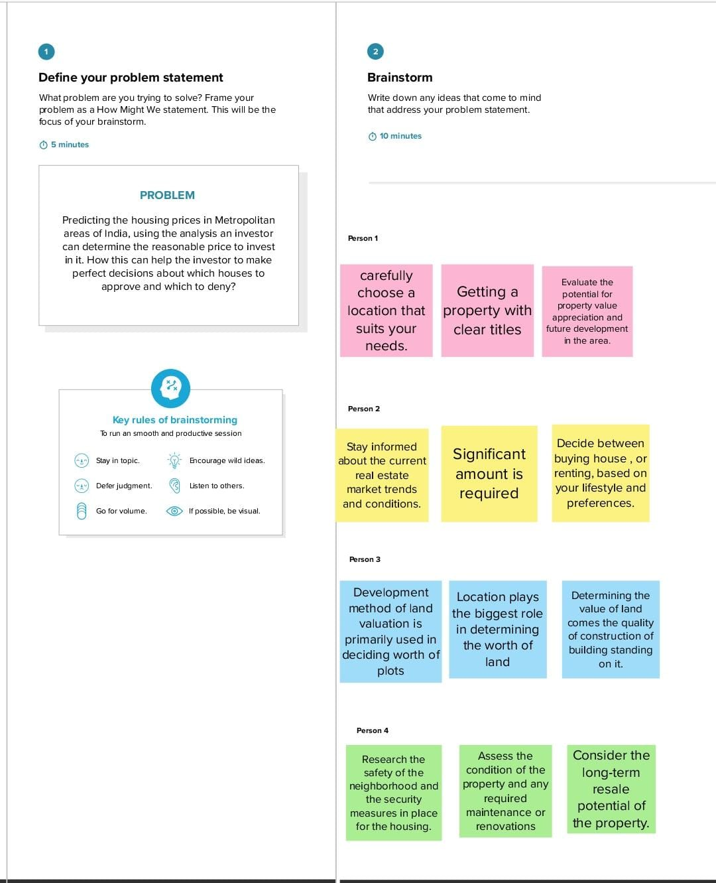

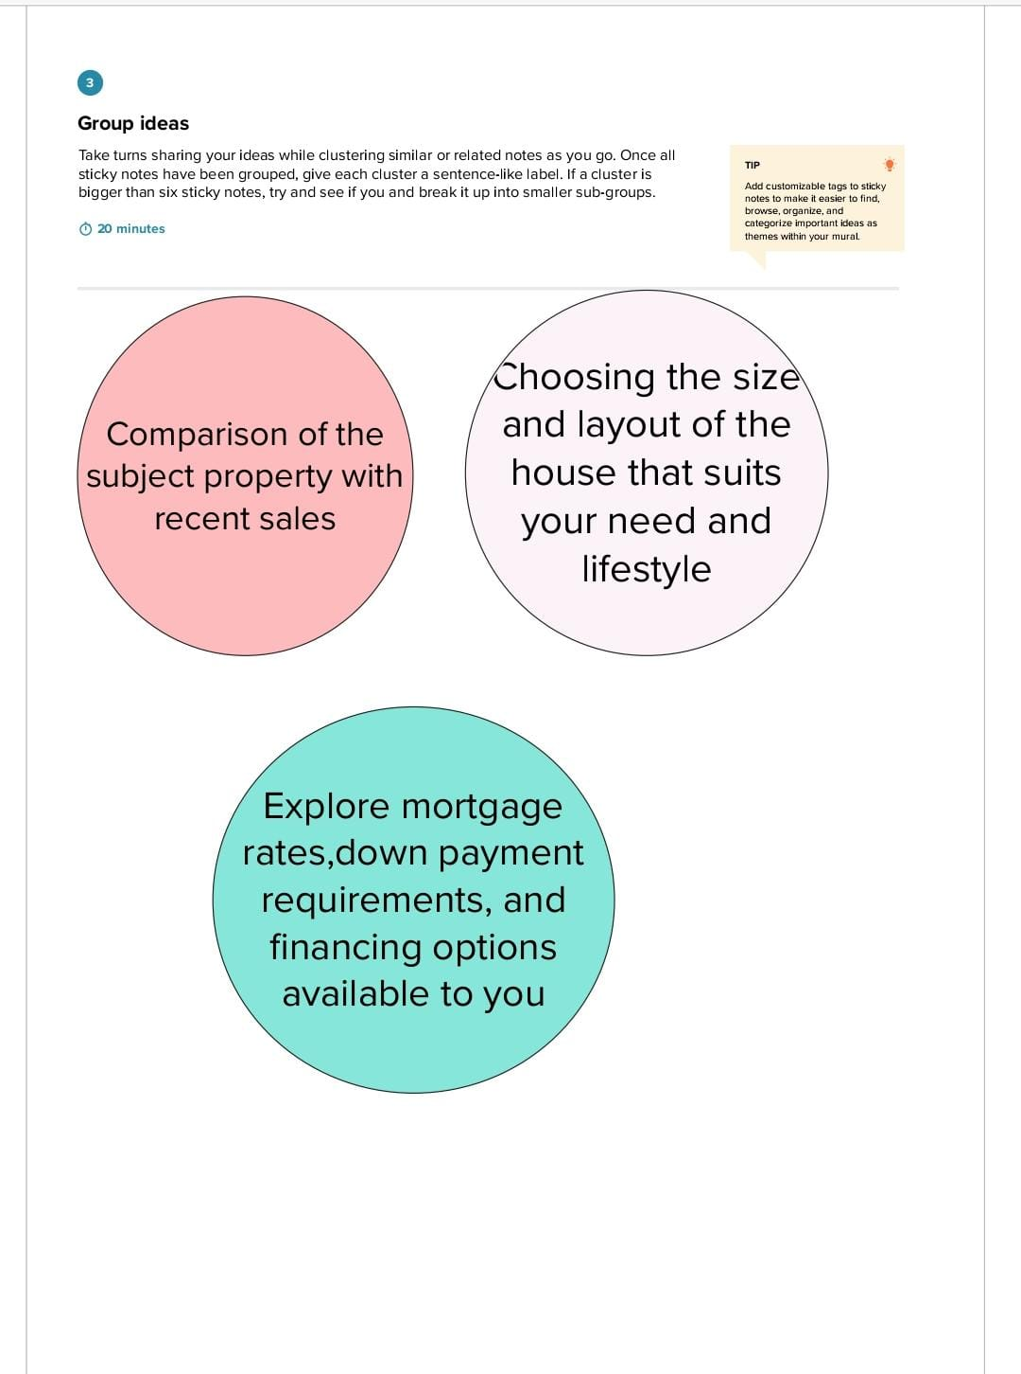

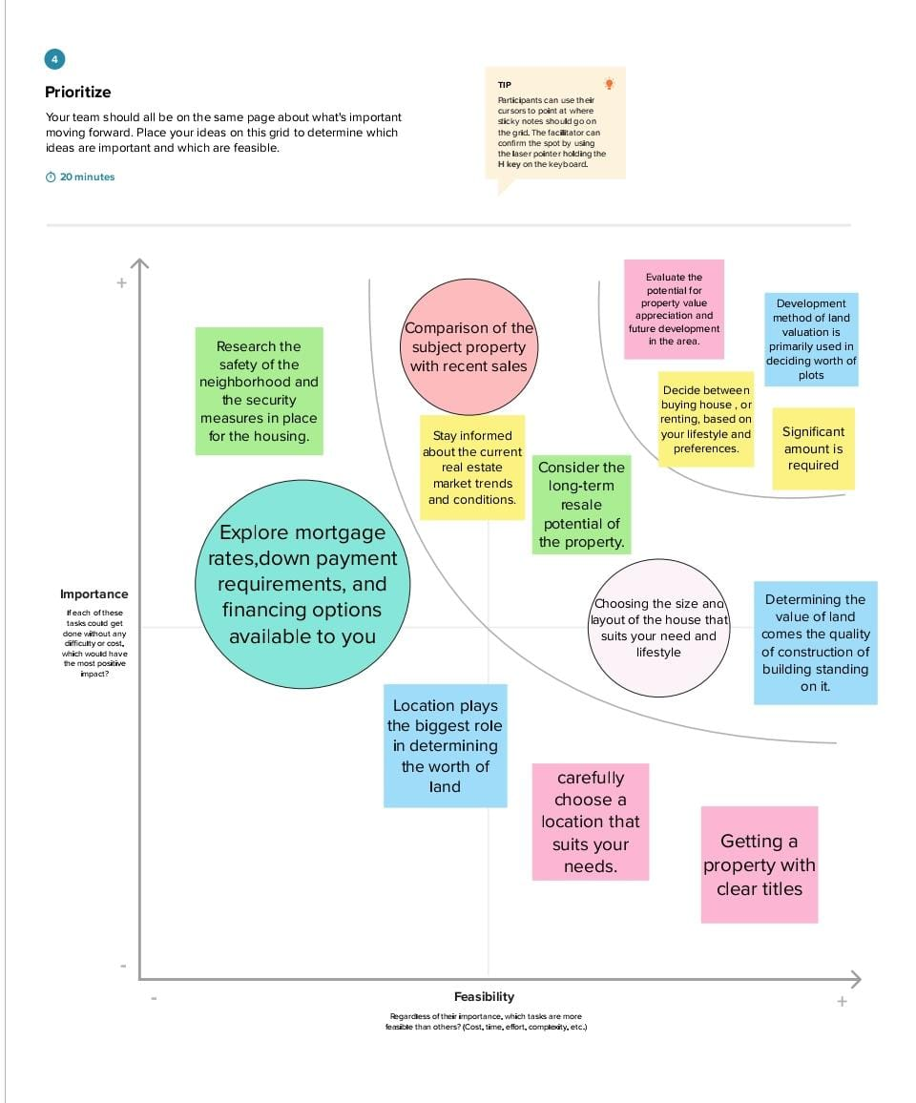

**3.RESULT** 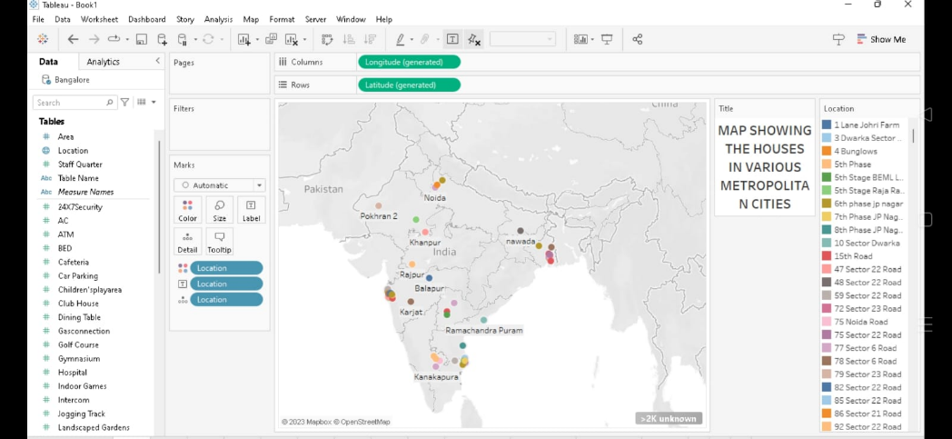

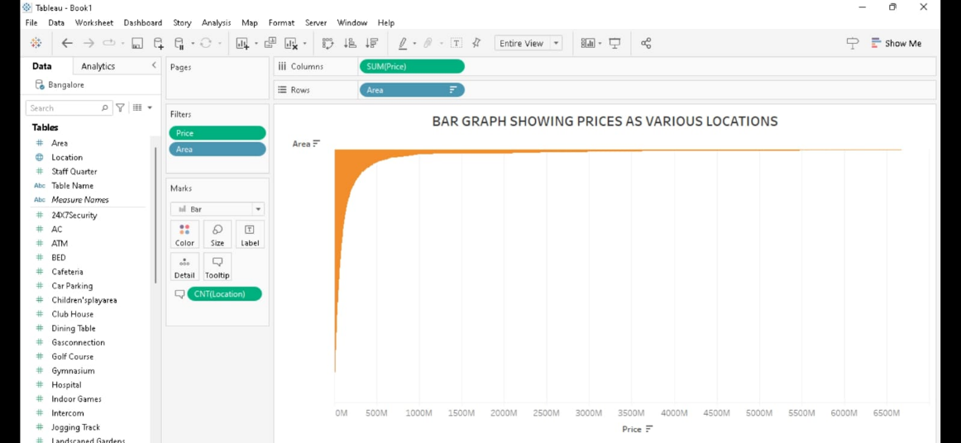

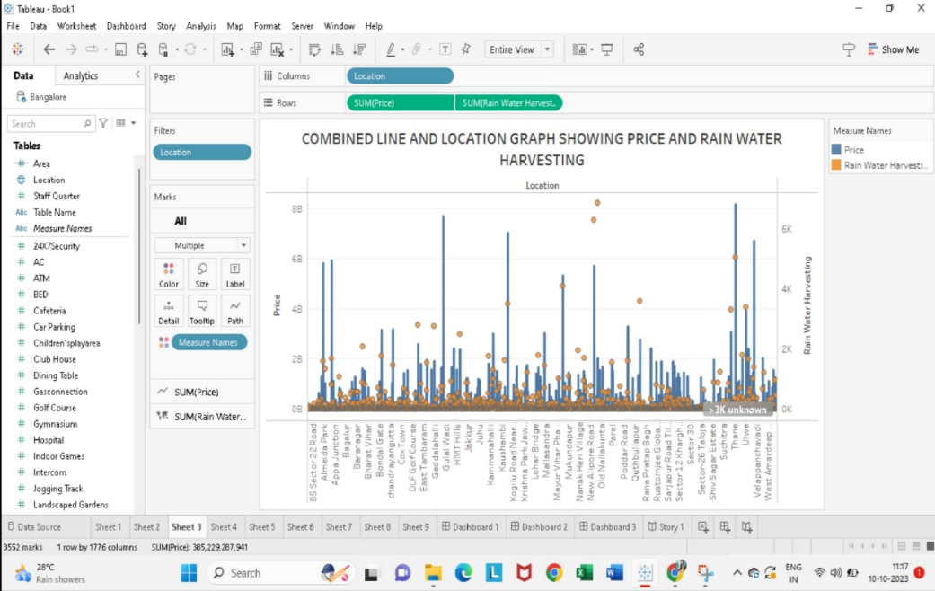

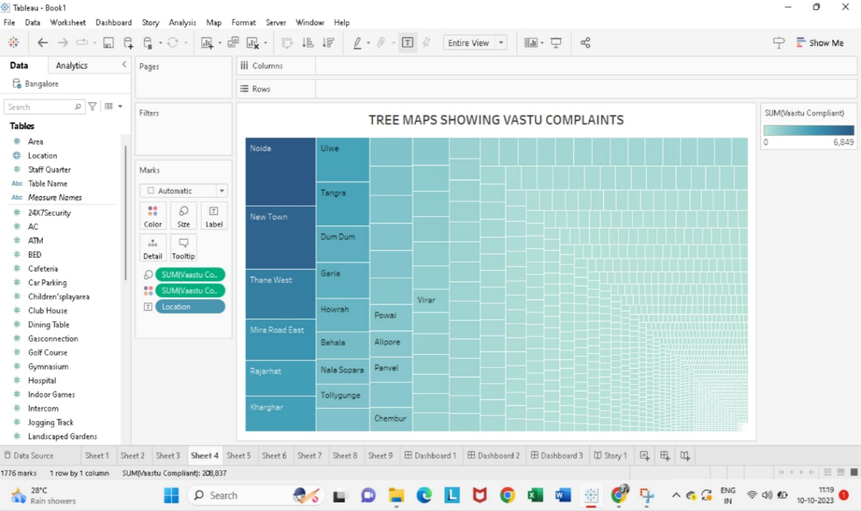

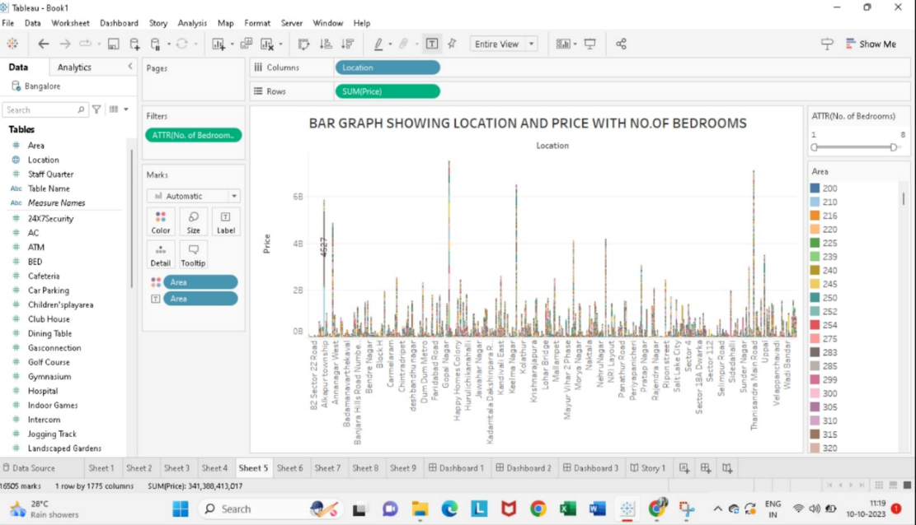

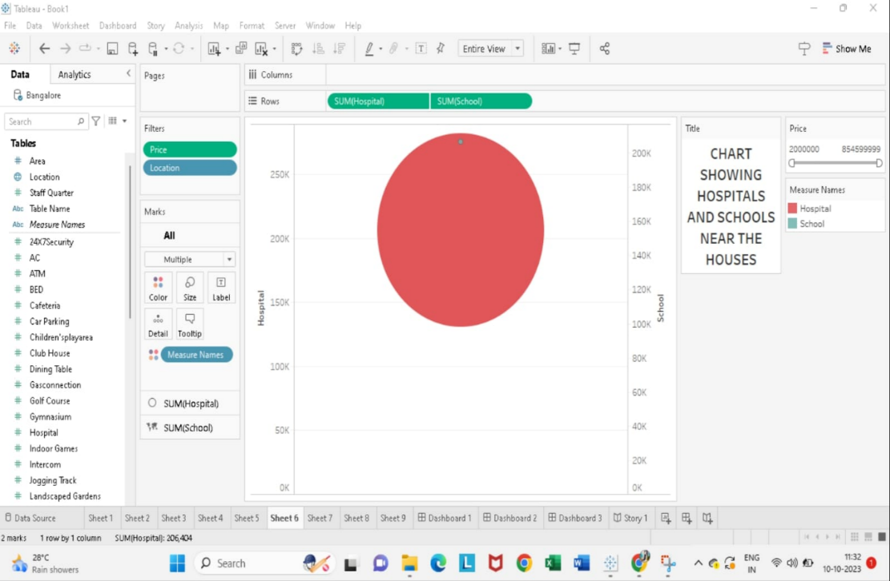

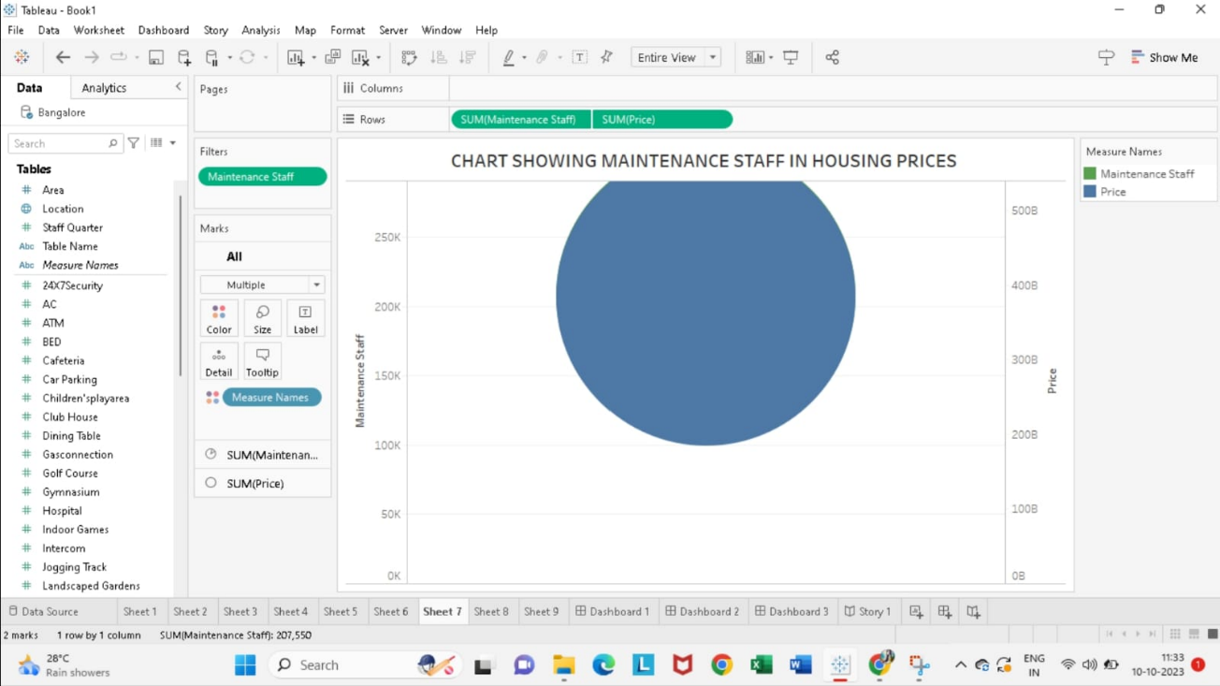

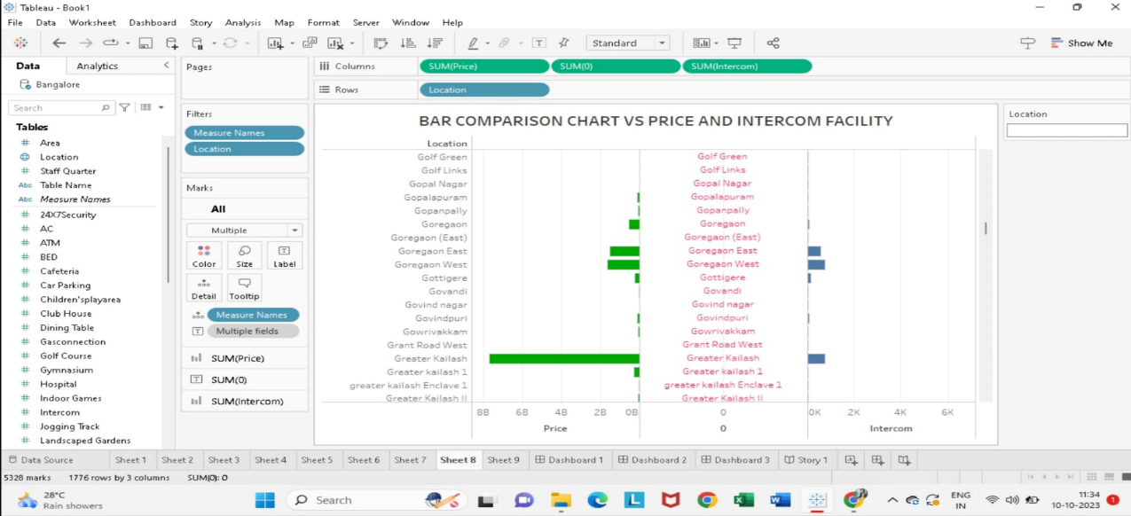

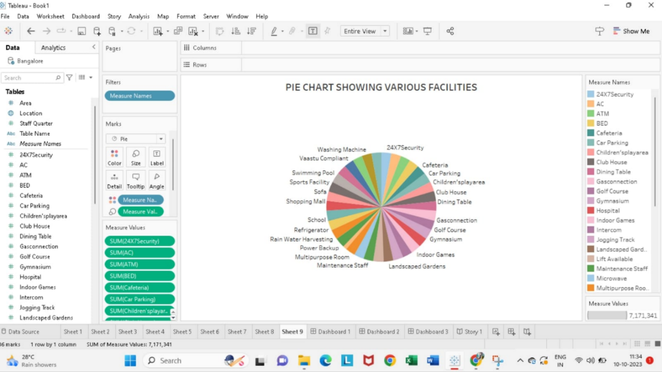

**4. ADVANTAGES AND DISADVANTAGES**

**ADVANTAGES**

1. Estimating property value
2. Calculating property Rentals
3. Predicting price appreciation
4. Improving home search experience
5. Targeted Advertising and Marketing
6. Property valuation
7. Risk reduction
8. Rental calculation
9. Better decision making
10. Improved customer’s engagement

**DISADVANTAGES**

1. Lack of Awareness
2. Complex modes
3. Data Risks
4. Way forward

**5.APPLICATIONS**

Help the developer determine the selling price of a house.

Increase transparency in the Indian real estate market.

**6.CONCLUSION**

This project examined and analysed the current research on the significant attributes of house prices and analysed the data mining techniques used to predict house prices. The accurate prediction model would allow investors or house buyers to determine the realistic price of a house as well as the house developers to decide the affordable house price.

**7.FUTURE SCOPE**

India’s real estate sector is expected to expand to VSD 5.8 trillion or VSD 5,833 billion by 2047. This estimated value will contribute 15.5% to the total economic output in 2047 from an existing share of 7.3%.